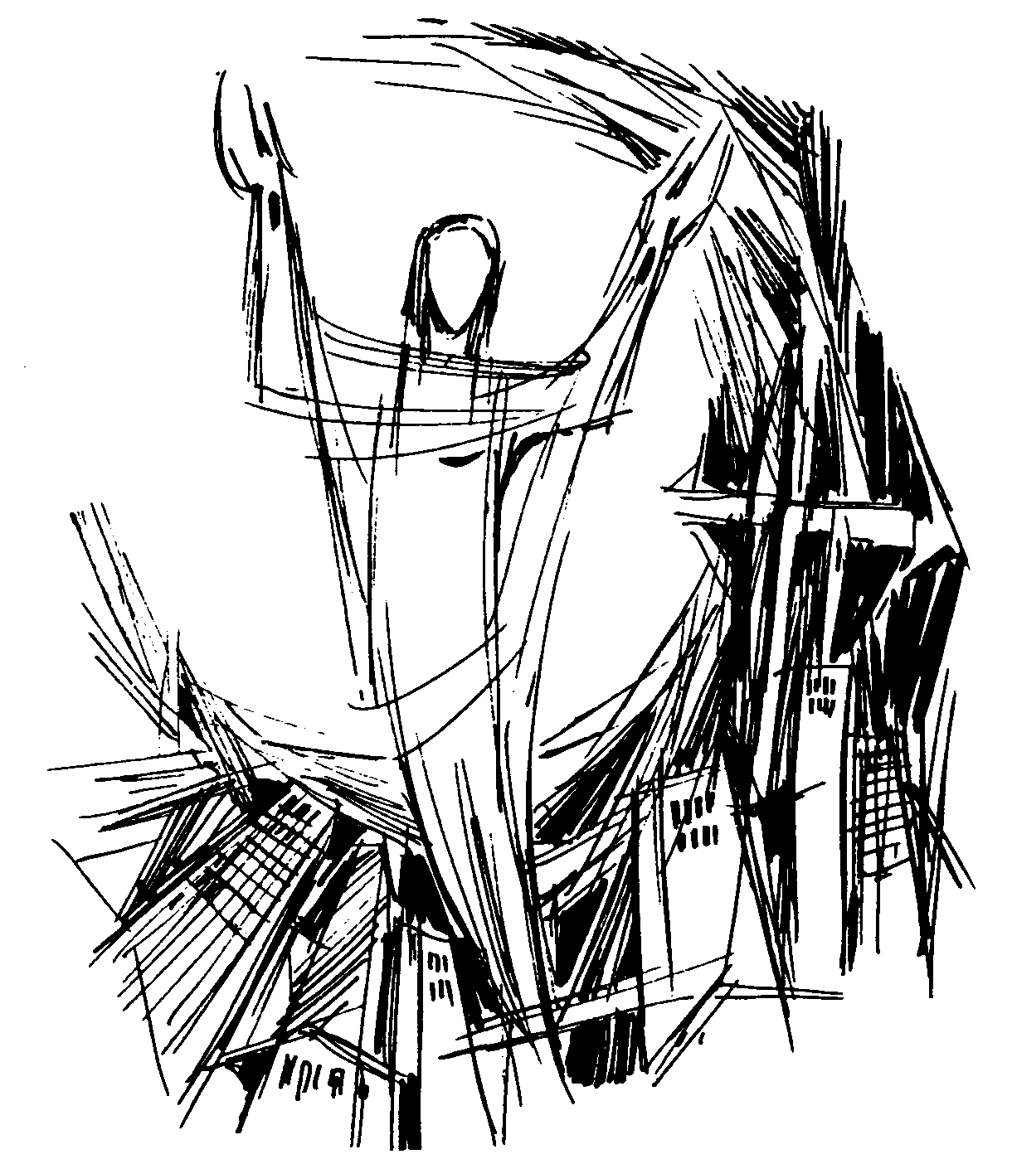
Assembly Mennonite Church
April 15, 2018

Eastertide: Friends of Christ

Welcome

Gathering
STS 10 Come! Walk in the light
HWB 311 The church’s one foundation

Scripture – I John 3: 1-7

Prayer of Confession (adapted from Dove’s Nest materials)
Loving God, you care for the needy and vulnerable among us. Children are always close to your heart.
Strengthen our resolve to defend those who cannot defend themselves. Help us make our congregation a place where your love and grace are experienced and where fear and harm are forever banished.
Make us your servants in caring for your beloved children. Amen.

Birthday Candles & Peace Lamp

Offering
STS 94 Sithi bonga

Children’s Time

Assembly Mennonite Church
April 15, 2018

Eastertide: Friends of Christ

Welcome

Gathering
STS 10 Come! Walk in the light
HWB 311 The church’s one foundation

Scripture – I John 3: 1-7

Prayer of Confession (adapted from Dove’s Nest materials)
Loving God, you care for the needy and vulnerable among us. Children are always close to your heart.
Strengthen our resolve to defend those who cannot defend themselves. Help us make our congregation a place where your love and grace are experienced and where fear and harm are forever banished.
Make us your servants in caring for your beloved children. Amen.

Birthday Candles & Peace Lamp

Offering
STS 94 Sithi bonga

Children’s Time

Listening
Scripture – Luke 24: 36-48**
Sermon

Response
HWB 282 Proclaim the tidings near and far
Sermon responses & prayer updates
Prayer

Sending
Welcome to visitors
Announcements
STS 16 Peace before us

You are invited in second hour to continue the conversation with Doug Hostetter and Thien Tran. Please return at 11a for a chance to respond to their words from this morning, ask questions, etc.

Leading in worship today: Song leader – Becky Snider; Worship leader – Jonathon Schramm; Children’s time – Thien Tran; Preacher – Doug Hostetter; Pastoral prayer – Tom Kauffman

**Children's bulletins based on today's scripture for ages 3-6 and 7-12 are available at the back of the Worship Space along with crayons and markers.

First time visitor? Outside of the worship space in the foyer you will find a podium where you can sign in and pick up a yellow Q and A handout. If you have children in Sunday School, classroom locations are posted on the bulletin board in the foyer.

Listening
Scripture – Luke 24: 36-48**
Sermon

Response
HWB 282 Proclaim the tidings near and far
Sermon responses & prayer updates
Prayer

Sending
Welcome to visitors
Announcements
STS 16 Peace before us

You are invited in 2nd hour to continue the conversation with Doug Hostetter and Thien Tran. Please return at 11a for a chance to respond to their words from this morning, ask questions, etc.

Leading in worship today: Song leader – Becky Snider; Worship leader – Jonathon Schramm; Children’s time – Thien Tran; Preacher – Doug Hostetter; Pastoral prayer – Tom Kauffman

**Children's bulletins based on today's scripture for ages 3-6 and 7-12 are available at the back of the Worship Space along with crayons and markers.

First time visitor? Outside of the worship space in the foyer you will find a podium where you can sign in and pick up a yellow Q and A handout. If you have children in Sunday School, classroom locations are posted on the bulletin board in the foyer.

