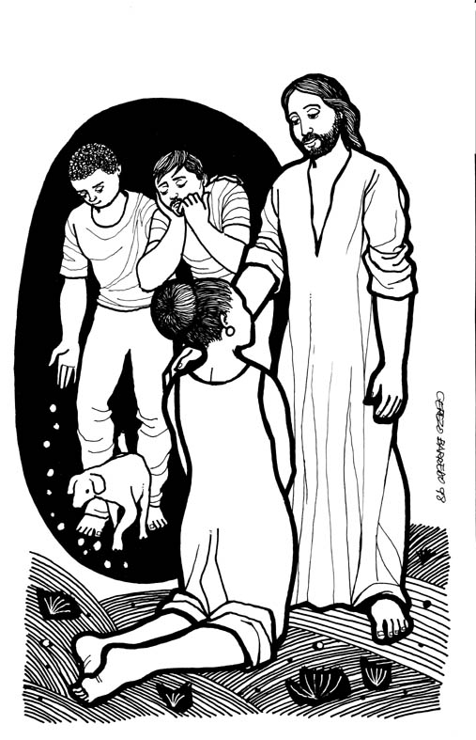
Assembly Mennonite Church
September 10, 2017
Jesus as our Companion
Jesus learns with us

Welcome ~ Bienvenidos

Gathering
SJ 27 God of the Bible
Peace Lamp
Christ Candle (adapted from Mt. 14:27)
Because we are hungry, in need of true bread,
Because we are sick, in need of healing,
Because we are fearful, in need of courage,
We turn to you, Jesus Christ, our companion. Teach us to hear your voice, saying over and over, “Take courage. I am here. Don’t be afraid.”

Covenanting : Char Yoder

Offering
SJ 8 Somos pueblo que camina/We are people on a journey

Children’s Time
STS 37 Firstborn of Mary
Children 2 and under are invited across the hall for story time; 3 and older may gather at the front of worship for the story

Listening
SJ 58 Who has known the mind of Jesus?
Scripture – Matthew 15:21-28**
Sermon

Response
SJ 53 O God in heaven
Congregational sharing & prayers
Sending
Announcements
SJ 94 Blest are they

Serving in worship today: worship leader – Jena Kennedy; song leader – Mary Lehman Yoder; children’s message– Susan Mark Landis; sermon – Tom Kauffman; pastoral prayer- Karl Shelly; Covenanting- Lora Nafziger

**Children's bulletins based on today's scripture for ages 3-6 and 7-12 are available at the back of the Worship Space along with crayons and markers.

2nd hour information:
All are invited in second hour to return to the sanctuary for a time of extended sermon response and sharing.
College students are invited to stay for second hour to meet with Lora Nafziger, one of Assembly's pastors, to enjoy some food together, and to discuss plans for the new school year in the Northwest side of multipurpose space.

Please remember to give any announcements to the worship leader during the service to read before sending at the end of first hour.

Sunday School classroom locations:
Infants: North Classroom (West side)
Toddler: Classroom off of Multipurpose space
Wee Wonder: Classroom beside church office
Pre-K: North Classroom (East side)
K: House across the street, South classroom
Gr 1: House across the street, North living room
Gr 2: Middle classroom, west side
Gr 3: Middle classroom, east side
Gr 4-5: South classroom, east side
Jr Youth: South classroom, west side
MYF: Room behind the kitchen

First time visitor? Outside of the worship space in the foyer you will find a podium where you can sign in and pick up a yellow Q and A handout.

