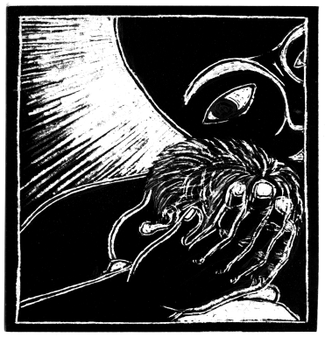
GATHERING
Music for gathering
Call to worship; Isaiah 61:1-4, 8-11

L: Awake! The invitation to carry light comes from the
God of restoration.
P: O God, you amaze us with your promise to build up the ancient ruins.
You say you will replace the ashes of the past with garlands of beauty.
Your bold vision dazzles our doubting souls.
L: Quiet our questioning souls.
P: Lead us beyond our fears and guide us on the path to peace.
Let it be whole.

Advent processional - Christe, Lux Mundi (handout)
“Christe, lux mundi, qui sequitur te habebit lumen vitae, lumen vitae”
Welcome
EXPECTING
Confession and Affirmation
HWB 184 Hark! The glad sound!

OFFERING
Building Project Recognition
Offering: STS 12 Magnificat

HEARING THE WORD
Children’s Time
Holy baby, Holy child (handout)
John 1:6-8, 19-28
1 Thessalonians 5:16-24
Luke 1:46b-55
STJ 13 My soul is filled with joy
Sermon
RESPONDING
Silence
Music for reflection
Sharing from our lives
Prayer
SENDING
Benediction
HWB 182 How Shall I receive thee
SECOND HOUR
Today in 2nd hour, you will have an opportunity to prepare for Advent in a contemplative manner through mandalas, meditating with icons, praying with candles and clay.

