Assembly Mennonite Church
June 24, 2018, Growing and Tending: Joy

I owe the Lord a morning song HWB #651
Welcome
Call to Worship
Jesu tawa pano (Jesus, we are here) STJ #6

Peace Lamp
L: As we light this lamp, let us sit in the stream of your love, shaded by the boughs of your mercy
P: We look to you, Divine Mother, for the healing of our world

Thou true Vine, that heals HWB #373

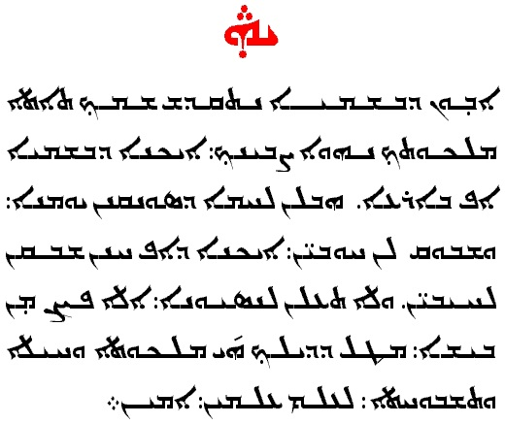
The Lord’s Prayer
Aramaic/Syriac text

Offering
He came down STJ #31
Prayer

Hearing God’s Word
Children’s Time
Scripture Psalm 98:4-9; John 16:22 Psalm 28:6-7
Stories of Joy
Instrumental Response

Communion
I come with joy to meet my Lord HWB #459
Instrumental music
Hallelujah! We sing your praises! STJ #88

Sermon Response and Sharing
Prayer
God’s Spirit is here (verses 1, 2 and 3)
Introduction of Visitors
Announcements

Sending
L: We came to worship
P: We go now to serve
L: We have been given the light
P: We go now to let it shine
L: We have been blessed by God’s love
P: We go now to share it
L: We are Christ’s disciples
P: We go now to witness to all.

Praise God from whom HWB #118

Worship Participants: Story Tellers: Oscar Quintana and Craig Glick-Miller; Worship Leader: Barb Swartley; Song Leaders: Alan Greaser and Jeannie Brunk; Scripture Readers: Wilma Harder; The Lord’s Prayer: Paul Keim; Peace Lamp: Marshall King; Children’s Time: Jonathan Schramm; Pastoral Prayer: Mary Lehman Yoder; Instrumental Response: Ben Good-Elliot; Special thanks to all musicians who bless us weekly with their gifts
The Lords Prayer (paraphrase of the Aramaic/Syriac text)
Abwûn O cosmic Birther, from whom the breath of life comes,
d'bwaschmâja who fills all realms of sound, light and vibration.
Nethkâdasch schmach May Your light be experienced in my utmost holiest.
Têtê malkuthach. Your Heavenly Domain approaches.
Nehwê tzevjânach aikâna d'bwaschmâja af b'arha. Let Your will come true in all that vibrates just as on the dense earth.
Hawvlân lachma d'sûnkanân jaomâna. Give us understanding for our daily need,
Waschboklân chaubên wachtahên aikâna daf chnân schwoken l'chaijabên. detach the fetters of faults that bind us, like we let go the guilt of others.
Wela tachlân l'nesjuna Let us not be lost in superficial things,
ela patzân min bischa. but let us be freed from that what keeps us off from our true purpose.
Metol dilachie malkutha wahaila wateschbuchta l'ahlâm almîn. From You comes the all-working will, the lively strength to act, the song that beautifies all and renews itself from age to age.
Amên. Sealed in trust, faith and truth.

