JESUS AS OUR COMPANION
“Jesus comes to us”
Assembly Mennonite Church
Aug. 20, 2017

Gathering
Welcome and introduction
HWB 580 My life flows on
“The storm is strong” (below)

Christ candle
L: Because we are hungry, in need of true bread,
Because we are sick, in need of healing,
Because we are fearful, in need of courage
We turn to you, Jesus Christ, our companion.
Teach us to hear your voice, saying over over,
All: “Take courage. I am here. Don’t be afraid.” (Matt.14:27)

STS 49 I will come to you in the silence

Offering ourselves and our gifts
HWB 558 When the storms of life are raging
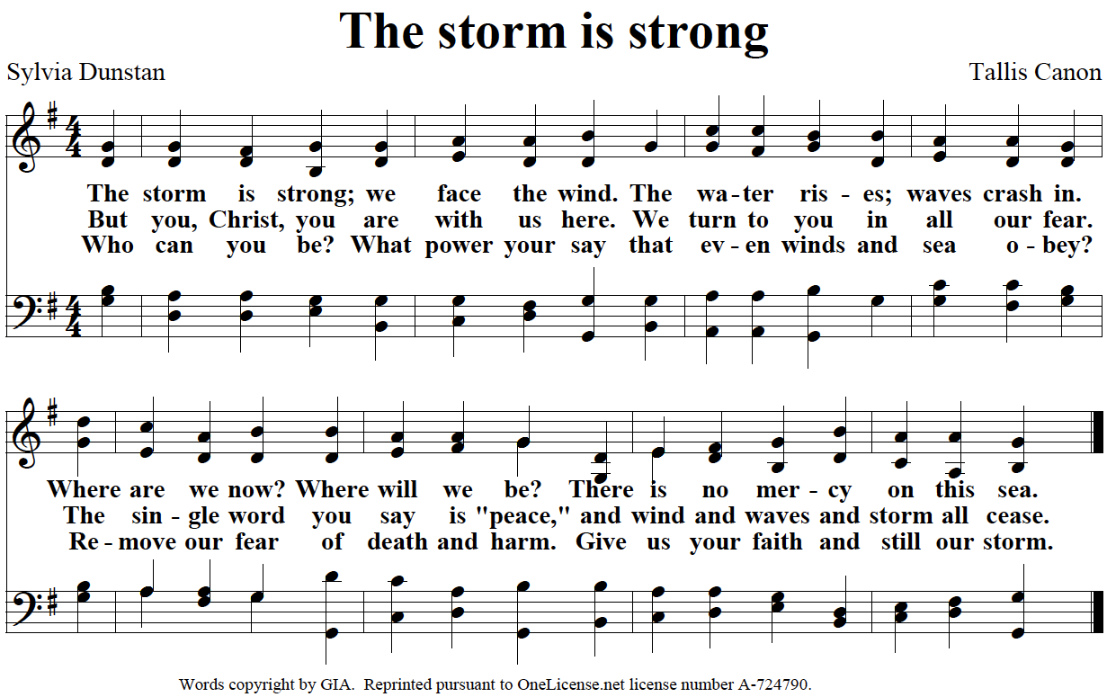
Listening
STS 37 Firstborn of Mary
Children’s time
STS 45 Calm me, Lord
Scripture: Matthew 14:22-33** (The Message)
Sermon

Responding
HWB 575 Precious Lord, take my hand
Sharing our lives
Prayer - Karl Shelly, pastor

Sending
HWB 603 Sometimes a light surprises
Benediction

Second Hour: Sermon response and sharing

Worship participants: Song leader-Bill Mateer; Pianist- Deanna Board; Worship leader-Anna Yoder Schlabach; Children’s time- Sean Smuts; Scripture reader-Kathy Meyer Reimer; Sermon-Carmen Horst; Visuals-Brian Yoder Schlabach.

**Children's bulletins based on today’s scripture are available at the back of the Worship Space .

Sunday School Classroom locations:
Infant: North classroom off foyer (West side)
Toddler: Classroom off Multipurpose space
Wee Wonder: Classroom by church office
Pre-K: North Classroom off foyer (East side)
K: House across the street, South classroom
1st grade: Across the street, North living room
2nd grade: Middle classroom, West side
3rd grade: Middle classroom, East side
4th & 5th grades: South classroom, East side
MYF: Room behind the kitchen

First time visitor? Be sure to sign in at the podium and pick up a yellow Q&A handout.

